2023

Rickcolet Benjamin-2201010382

Jamorio Downer- 2201011535

Camoy Edwards- 2201011768

Shemar Campbell-

4/28/2023

MYSTIC COMPUTERS

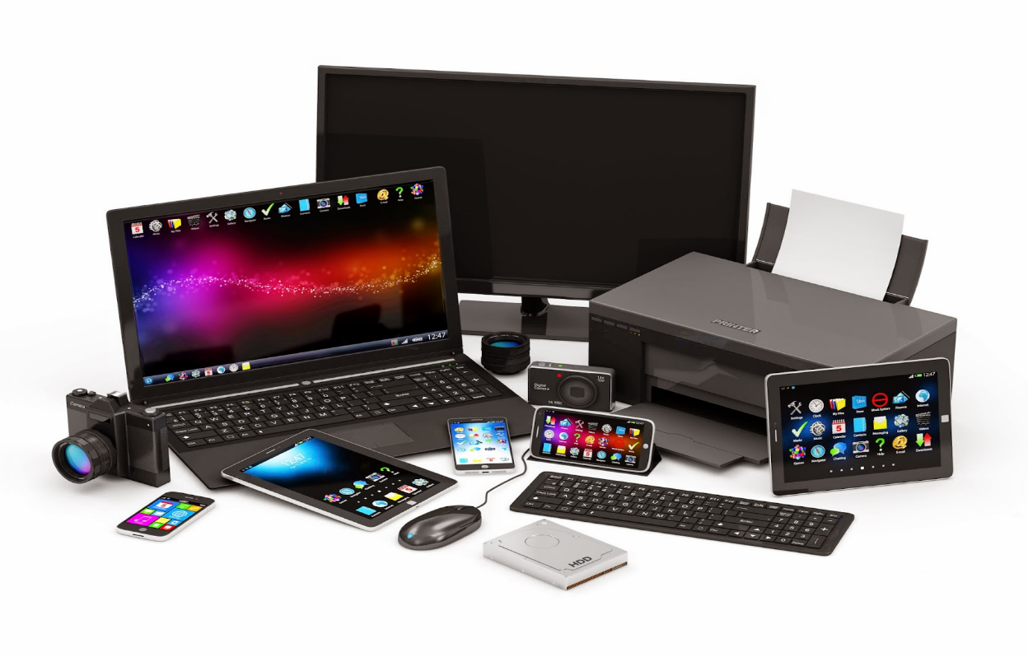

Contents

Team Profile 2

Company Profile 3

Questionnaire for customers 4

Website Goals 5

Audience definition 5

Functional Requirements 1

Non-Functional Requirements 1

Site Features 1

Site Structure 1

Wireframe 1

Page Mockup 2

Content Inventory 3

Visual Design/Screenshots 4

# Team Profile

Team members and their roles: before assigning each role, each members strength and weaknesses were assessed.

1. Rickcolet Benjamin - support page and create documentation for project
2. Jamario Downer- Home page and other
3. Shemar Campbell – Category Page
4. Camoy Edwards- Saved list page

Our team created a WhatsApp group in which any questions and suggestion could be sent and received. We met on Microsoft teams if needs deemed necessary to demonstrate various stages of our website.

While doing this project our team encountered many challenges such as:

* time management - each member of our team has a 9-5 job and family in which require majority of our time, which resulted in lack of meeting time and minimal time to work on the project. In order to combat this challenge, members were given permission to post any questions within the WhatsApp group at any given hour of the day and weekends were utilized for meetings.

# Company Profile

Mystic Computers is a local electronic store, formed in 2022 and is located at 26c Barbados Avenue, Kingston, Jamaica. We can be reached via email at [mysticcomputers@gmail.com](mailto:mysticcomputers@gmail.com) or via telephone at (876)918- 1818 / (876)525-2522.

We aim to be the #1 provider of seamless secure innovative technology and services for a connected world.

The products we offer are elite brand Printers/Scanners, Ink, Chargers and Tonner and other computer accessories. We also assist with fixing damaged computers and laptops, even phones.

Rickcolet Benjamin, Camoy Edwards, Jamario Downer and Shemar Campbell all decided to start Mystics Computers because we realize that quality and inexpensive electronic devices such as computers and laptops where very hard to get in Jamaica as students.

The original purpose of this company was just to sell devices to students, but as time progressed, we found that we could also be helping others, not only students, hence why we begone expanding our company by creating several social media platforms such as Instagram and Facebook and also by providing other computer/ laptop accessories and services. Our social media followers grew tremendously over the past 5 months resulting in us getting approximately 10-15 orders a day.

We however met a stumbling block when we realize a lot of orders were being over looked because of the countless number of messages we received daily. We were starting to lose customers rapidly, until we opened our first store in New Kingston. This was a huge milestone for us, our customers started returning, they could now walk in store to get whatever they need at their convenience.

We at Mystic Computers value our customers dearly and is constantly looking for ways to better serve you and to grow.

# Questionnaire for customers

This questionnaire is anonymous, please answer the following questions.

1. On a scale of 1-10, how satisfied are you with our product/service?
2. How did you hear about our company?
3. What problem were you trying to solve with our product/service?
4. Did our product/service meet your expectations? If not, why?
5. How easy was it to place an order?
6. Did you face any challenges while ordering? If yes, please explain.
7. Would you recommend our product/service to others? Why or why not?
8. Is there anything we could have done to improve your experience with our company?
9. Any additional comments or feedback?

# Website Goals

Goals we wish to accomplish with our website

1. Establish an online presence and increase brand awareness
2. Generate leads and increase sales
3. Provide customer support and improve satisfaction
4. Share information and educate our audience
5. Build a community and engage with customers
6. Showcase our products or services

# Audience definition

Our target audience is mostly students as they are always in need of new devices for school and these individuals are tech-savy and always online. This age group, tends to do things at their convenience therefore the website will be very handy for them. We are also targeting corporate companies to supply their electronic needs for their staff.

# Functional Requirements

Here are some functional requirements of our website:

1. Product catalog and search functionality
2. Shopping cart and checkout functionality
3. Customer support functionality, such as a faq and contact forms
4. Savedlist functionality
5. Product reviews and ratings functionality
6. Inventory management functionality
7. Sales and promotions functionality, such as discounts and coupon codes
8. Search functionality.
9. Content management system for website administrators.
10. E-commerce functionality.
11. Social media integration.
12. Responsive design for mobile devices

# Non-Functional Requirements

Here are some non-functional requirements for our website:

1. Performance: Our website should load quickly and reliably to provide a good user experience.
2. Scalability: Our website should be able to handle a large number of users and transactions without slowing down or crashing.
3. Usability: Our website should be easy to navigate and use, with intuitive interfaces and clear instructions.
4. Accessibility: Our website should be accessible to people with disabilities, with features such as screen readers and keyboard navigation.
5. Reliability: Our website should be reliable and available at all times, with minimal downtime or errors.

# Site Features

Our website has features such as:

* Shopping cart
* Sign In
* Notification
* Product search functionality
* Product pages
* Support page

# Site Structure

# Wireframe

# Page Mockup

Our page mockup was done using Adobe Photoshop.

Home Page

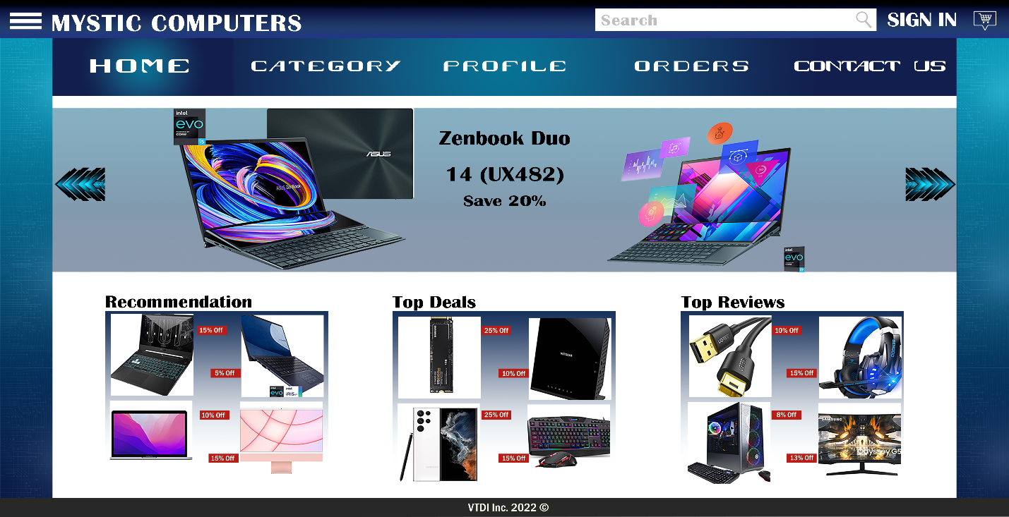

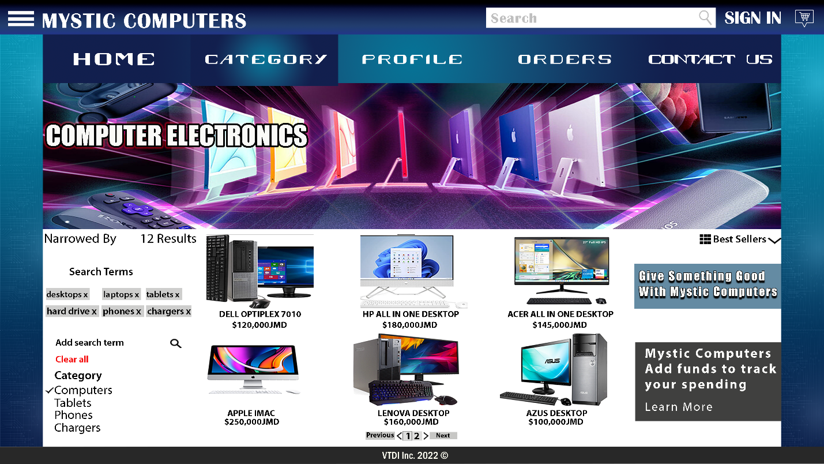Category Page

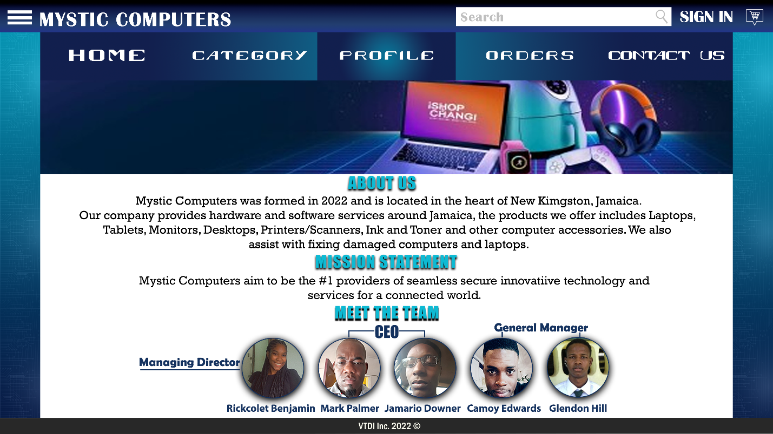Profile Page

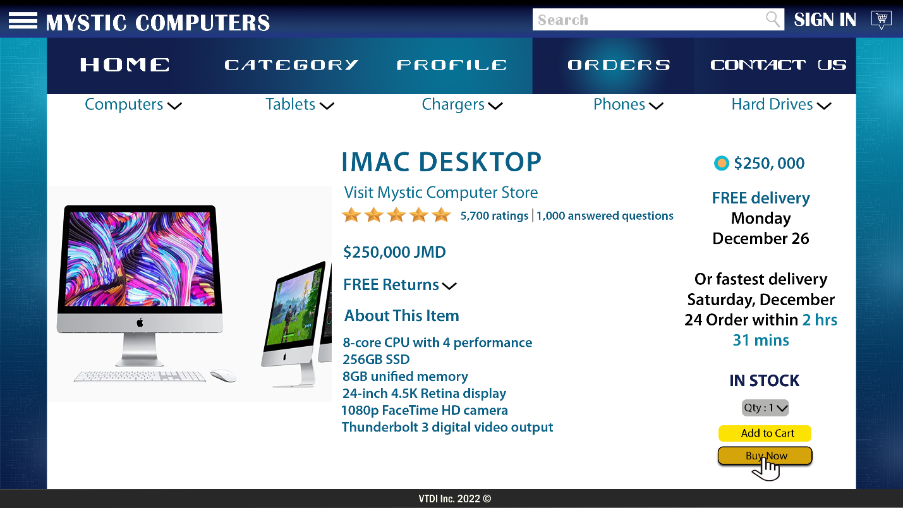Order Page

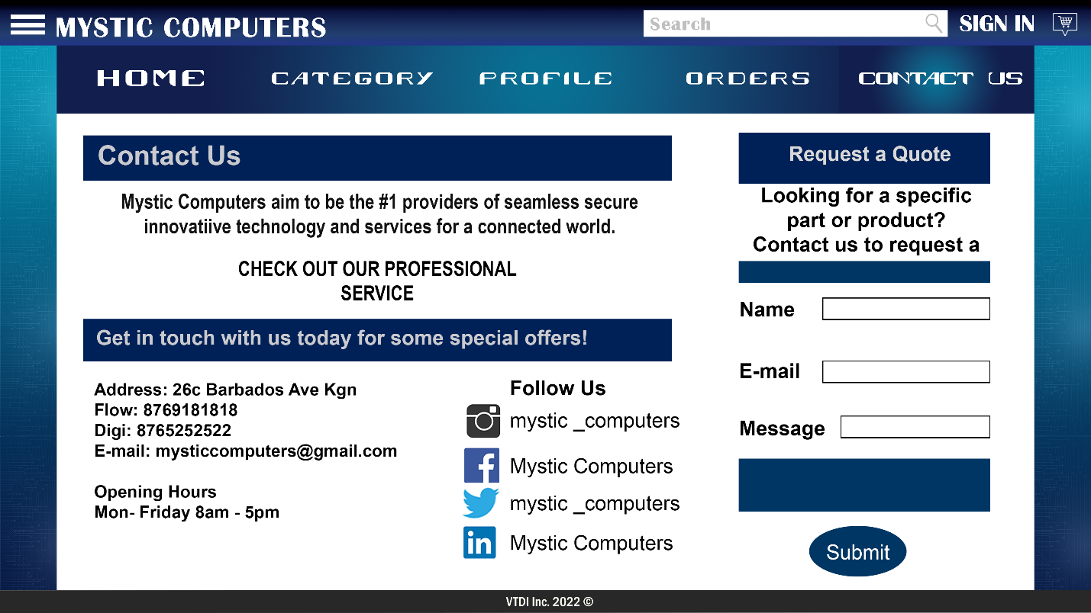Contact Us Page

# Content Inventory

# Visual Design/Screenshots